List of Requirements:
- Functional
  - Alert the user when the temperature is hot
  - Alert the user of the distance to the surface
- Non-Functional
  - Comfortable
  - Does not interfere with the user
  - Will not break
- Constrains
  - Wire management may be an issue
  - The orientation of the user’s hand will have an effect on the functionality
  - The user may burn themself if the glove does not protect them properly
Table
Input | Output | Purpose
Temperature Sensor | Buzzer | Will alert the user if the temperature is above a comfortable level, to ensure that the user does not burn themself.
Ultrasonic Range Sensor | Vibrator | Will alert the user the distance to the surface through the feedback of a vibrator, the intensity and frequency of vibrations will alert the user of the distance.

Inputs:
- Temperature Sensor
- Ultrasonic Range Sensor
Outputs:
- Vibrator (To alert user of the distance to the surface of an object)
- Buzzer (For sound to alert the user when the temperature is hot)
List of products required:
- Temperature Sensor
- Ultrasonic Range Sensor
- Buzzer
- Vibrator
- Breadboard
- Thick Material Glove, Link
- Wires
- Electrical tape (For wire management), Link
- Raspberry PI
- Velcro cuff, Link

- Refine the sketch of your product.
  - this should clearly show all the inputs and outputs, as well as the wearability, portability, and/or mobility of your product.

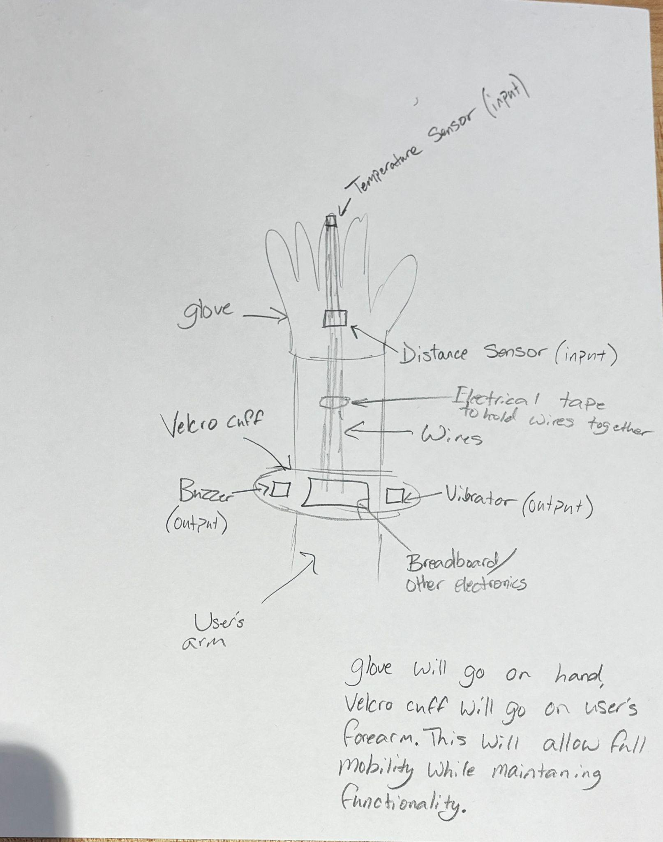

- Define the state diagram showing how the product works (see diagram below for reference)

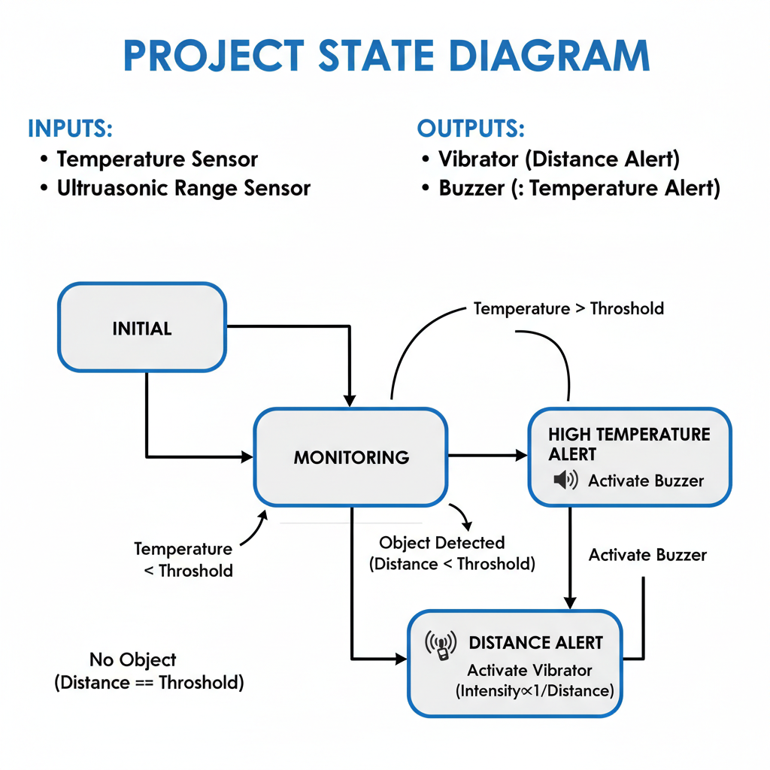

- Create the Gantt Chart for your development (see figure below for reference)
Final Project Gantt Chart

